* **Connect to the Store Sales Data and do the following**

Remove all the blank rows.

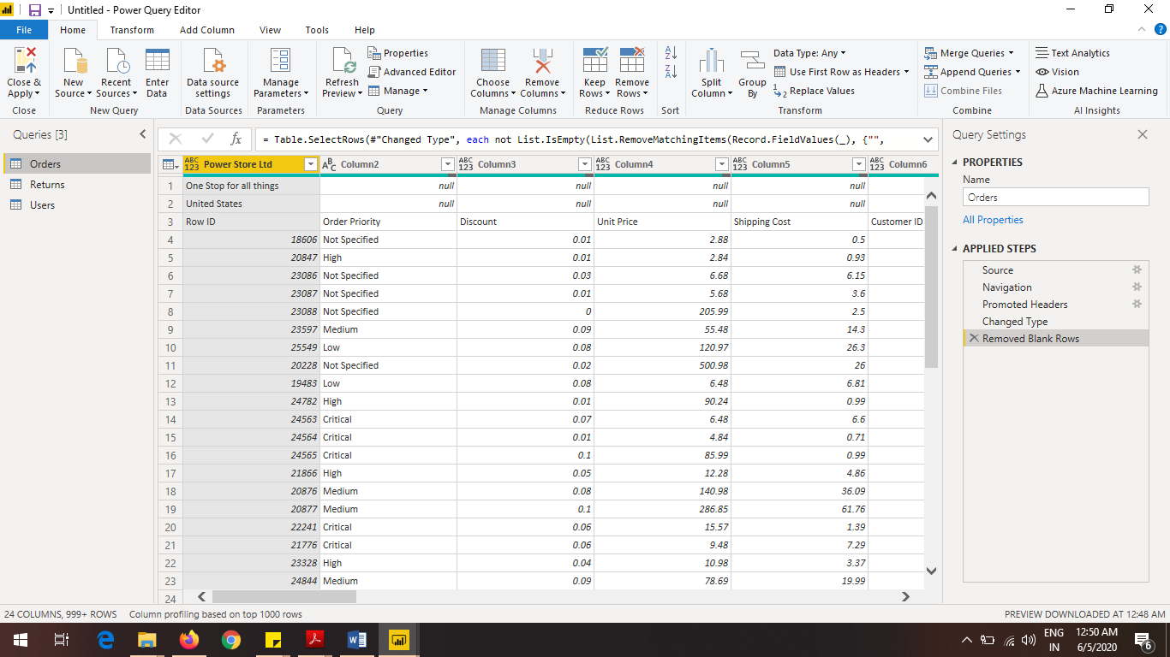

Update the column header if they are not updated

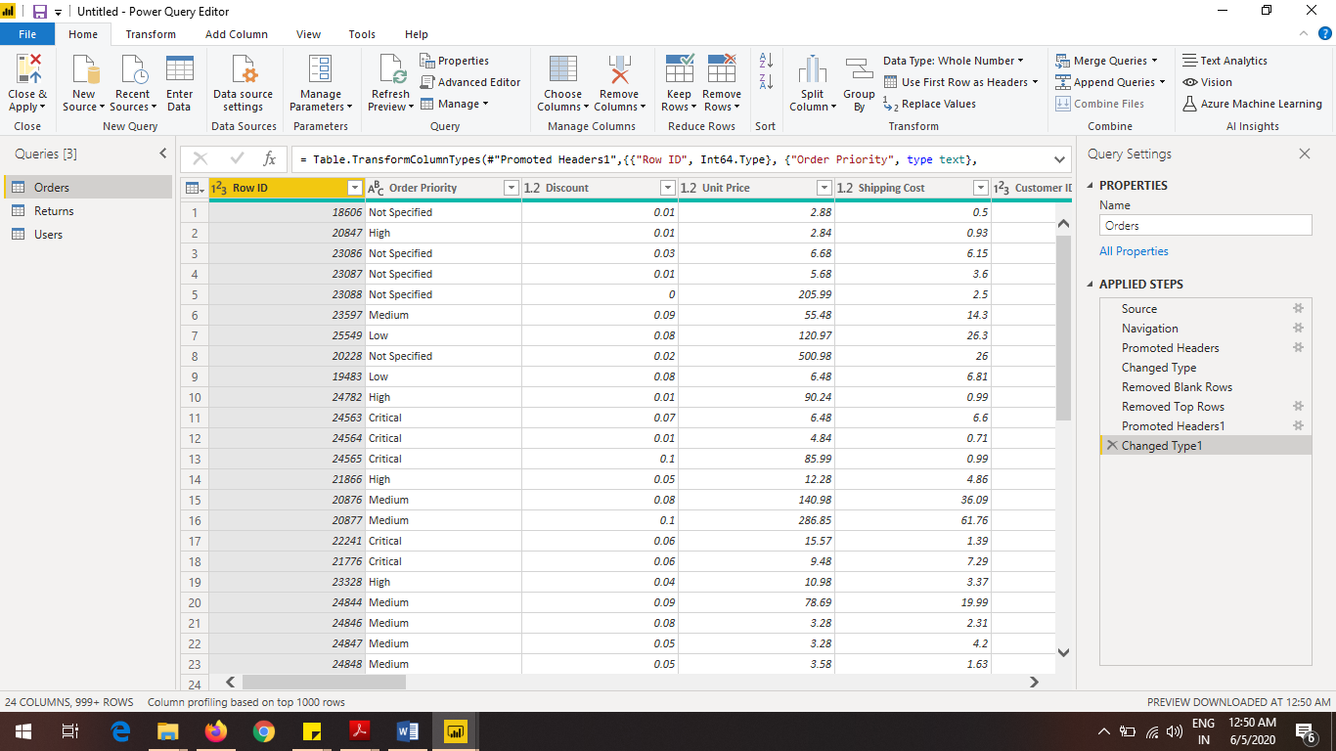

* 1. Create a text table and show the sales in terms of
  2. o Customers
  3. o Product Category
  4. o Regions

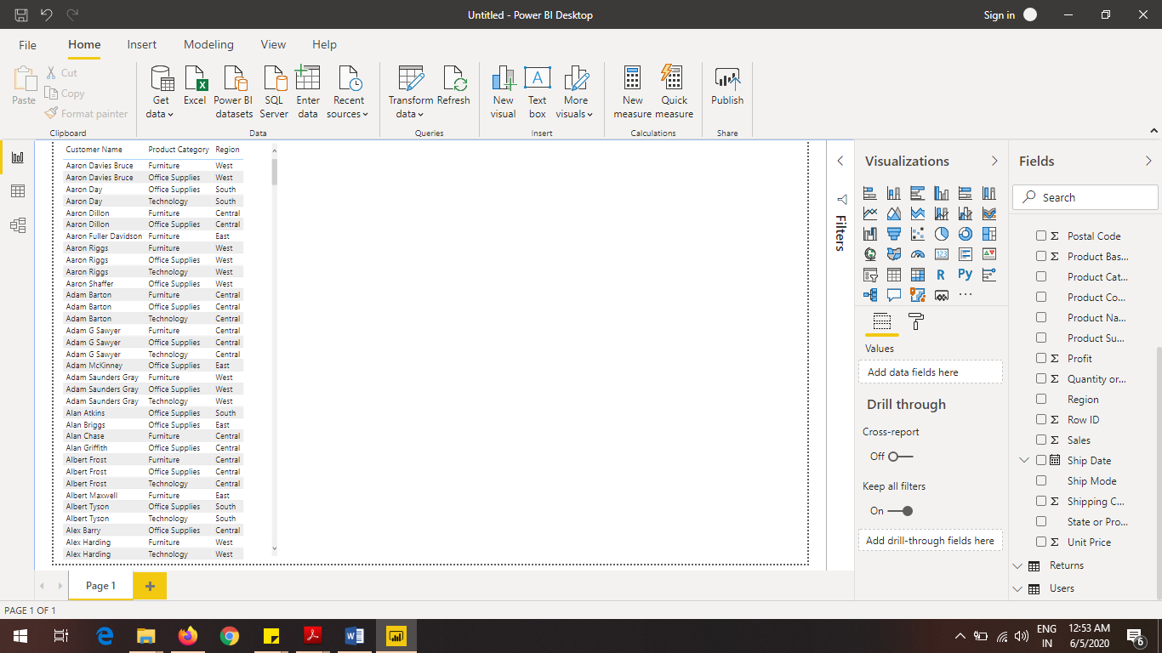

* **Create a line and Clustered Column Chart showing the Sales and Discount as per the State or Province**

− Format the bars and line with different colors

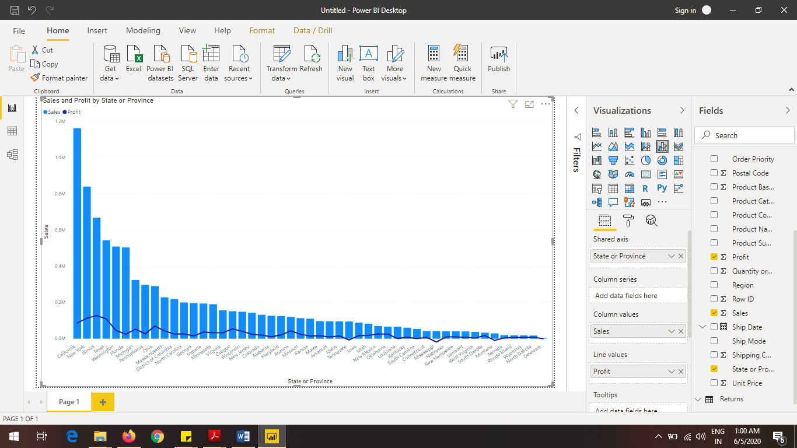

Which state has the highest sales in terms Technology?

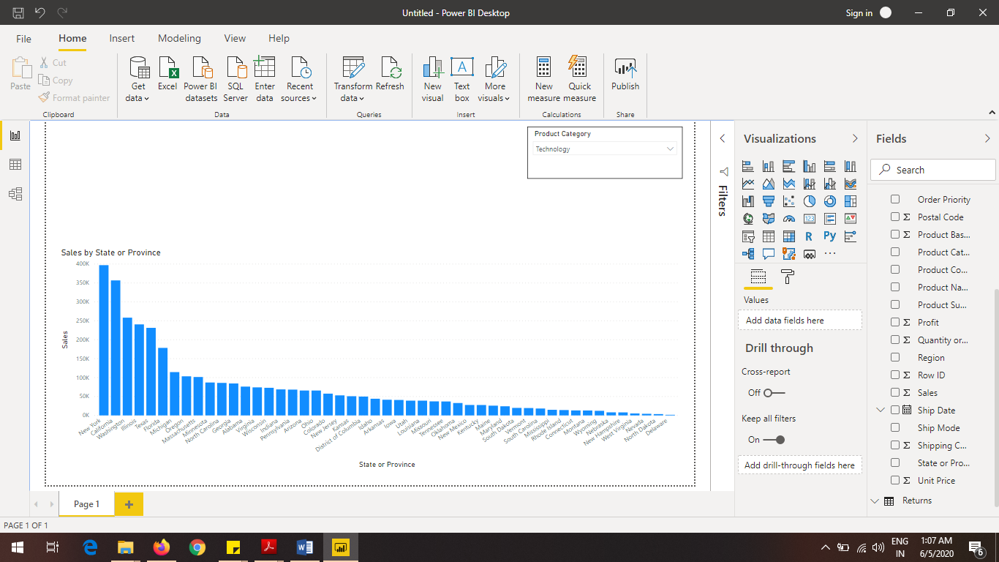

* **Create a** *Donut Chart* **showing sales in terms of Product category**

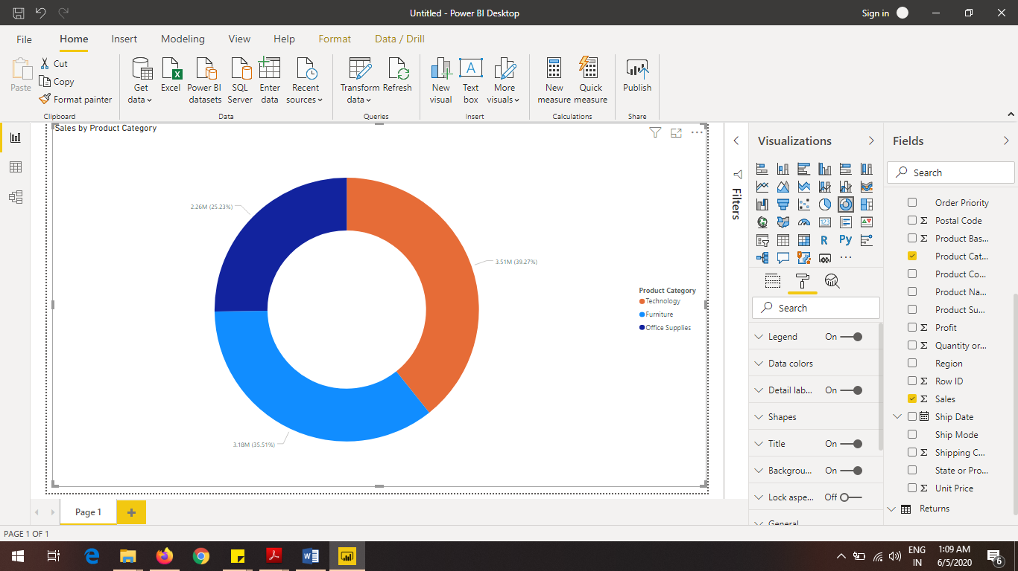

 **Create a** *Slicer* **and show the regions in dropdown. See how all the visuals mentioned above behaving when a particular region is selected.**

